"It'll be alright by Friday" – traffic response to capacity reduction
Dr. Richard G. Clegg (richard@richardclegg.org)
Research Assistant
Department of Mathematics, University of York (YO10 5DD)

Abstract
This paper looks at traffic response to network change that reduces road capacity. Data was collected in the city of York (UK) to investigate driver response to a planned capacity reducing intervention. Licence plate surveys in York monitored the situation before and during a planned event that lowered the capacity of a road by closing one lane of a two-lane road. The event is analysed in terms of flows and travel times to consider how the closure impacted on driver behaviour. A model is fitted to the data with an initial change followed by a linear return to normal. This is an analogy to the engineering rule of thumb that an initial change to a transport system that seems disastrous on Monday will “be alright by Friday”.

1. Introduction
This paper describes statistical analysis of the traffic response to a capacity reduction. The study was part of EPSRC funded work and took place jointly with the Institute for Transport Studies, University of Leeds. As part of this work, a large licence plate survey took place in York to investigate the partial closure of a section of York’s inner ring-road. The roads were surveyed in advance of the closure and during the closure in order that the effect of the closure on drivers could be analysed. The survey data are available online: gridlock.york.ac.uk/route.
In a previous paper (Clegg, 2005), this data set was analysed to consider matching between days. In this paper, the data set is analysed to look at how travel times and flows are affected by the closure. In specific, a model is fitted which assumes an initial transient effect after closure followed by a “return to normal” effect. This is in line with the often quoted engineering rule of thumb “It’ll be alright by Friday”, that is to say that an initial change to a network which seems major on Monday may well be showing much less effect on the following Friday.
In section two of this paper the survey methodology is outlined. In section three the statistical techniques used (t-test and General Linear Models, both well-known techniques) are described. In section four initial data analysis is performed to consider the effects of the closure on the flows on individual sites. In section five the preprocessing necessary to consider data matches across site pairs is described. Finally, in section six a model is fitted to the preprocessed data. The model fits travel time and flow changes as a result of the capacity reduction. The model shows statistically significant results for many but not all of the site pairs examined.
The context of this study was an interest in the subject of road capacity reduction following the publication of a report by Cairns et al (1998). This report considered a number of cases where monitoring had looked at incidents which reduced the available road capacity. One conclusion of this report was that capacity reduction in a network often resulted in a reduction of traffic levels over the network. Another conclusion was that there was a volatile response in the first few days of a scheme. Batley and Clegg (2001) report on studies that consider driver route choice and departure time choice.

2. Survey Description
The survey around which this paper is based involved surveying fourteen days at eleven sites in York. York City Council closed one lane of a two-lane one-way road (Fishergate) that was part of the city’s inner ring road. The survey looked at those streets that were most likely to be affected by the closure. Survey sites were picked with the idea of looking at traffic that was moving anti clockwise around the city, particularly the traffic crossing the river from southeast to northwest. At each site, partial licence plates were manually recorded for the entire morning rush hour. More information about this data set can be found in Clegg (2003) and Clegg (2004).
Figure 1 shows the survey sites used for the Fishergate Survey. All sites are monitored only in the direction of the arrows given. The closure being investigated was based around works to repair a collapsed sewer at site A. The repair work involved a partial closure of site A, essentially one lane being removed from the road. Six days were surveyed before the closure and eight days during (although on one of them the closure was temporarily removed because of races taking place in the city – these generate considerable traffic).
The surveys were all morning peak hour surveys. The surveys ran from 7:45 – 9:15 except for sites H, I and J. Because they would be reached later these were surveyed from 8:00 – 9:30 in order to increase the number of matches.
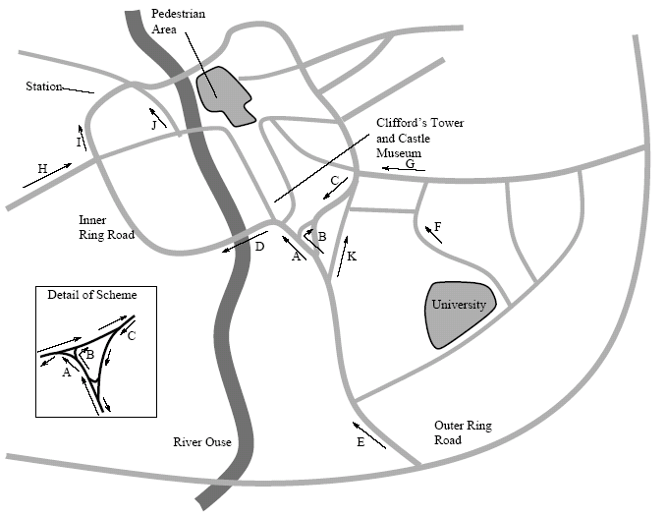
Figure 1: Fishergate Survey Sites

The closure was originally scheduled to last only two weeks and therefore the plan was to survey for one week before, one week during and one week after the closure. However, the closure was extended to four weeks and therefore no true after survey data is available. A possible exception is the 13th of July when the closure was suspended for one day to allow for the increase in traffic due to a major horseracing event that weekend (the extra traffic due to the race-goers is thought not to have had a great effect on traffic during the morning peak since it would have been later in the day). The days surveyed were as follows:
- 25th, 26th, 27th, 28th, 29th June and 2nd July: before surveys.
- 3rd, 4th, 5th, 6th, 11th, 12th July - during survey.
- 13th July - temporary removal of roadworks (this could be seen as an after day).
- 16th July - during survey (roadworks back in place).
For the Fishergate survey, for most sites, the traffic was monitored from 7:45 to 9:15. This was in order to catch all of the rush hour traffic and a quarter of an hour window either side. However, at selected sites, this window was adjusted to monitor from 8:00 to 9:30. This happened at those sites that would be reached last on a journey (for example, in Figure 1 site J would always be reached after site A). This was decided since the travel time between some pairs of sites was of the order of half an hour. Without such an offset some of the survey time would otherwise be wasted since the earliest (or latest) parts of the data could not be expected to match with data at any other site. The sites that were surveyed from 8:00 to 9:30 were sites A, I and J.
Timing on both surveys was performed by asking the surveyors to record the time at approximately five minute intervals. Surveyors were supplied with synchronised watches at the beginning of the surveys. The times for data between each time stamp are interpolated so, for example, if there are ten plates between a time stamp at 8:10 and one at 8:19 they will be split so that one plate is seen in each minute. Because of this interpolation and possible rounding of the time, the times recorded can only be assumed to be accurate to within five minutes, however, it is hoped that it is accurate to a much greater resolution than this.
3. Statistical Techniques Used
A t-test is a standard method for testing the hypothesis that two means are equal. See Hoel (1984) page 148 for the full mathematical details. If X and Y are the means of two data sets then a two-tailed t-test attempts to distinguish the hypotheses,
$$\begin{aligned}H_{0}:X=Y \\ H_{1}:X≠Y\text{.}\end{aligned}$$
Given certain assumptions about the data (mainly that the means are independent normal variables although the method is usually regarded as not too sensitive to minor violations of this assumption) then the t-test can assign a p-value. The p-value for a t-test is the confidence level at which the null hypothesis H₀ can be rejected. If the p-value is near zero then the null hypothesis should be rejected (it is likely that the means are different). If the p-value is near one then the null hypothesis should be accepted (it is likely that the means are the same). A middling p-value indicates that the t-test cannot reliably distinguish between the hypotheses and no conclusion can be reached from the data about whether or not the means are equal.
A General Linear Model or GLM (not to be confused with a Generalised Linear Model) assumes a linear relationship between a quantity and a number of dependent variables.
$$y=β_{0}+\sum{β_{i}x_{i}}+ε,$$
where y is the variable to be estimated, the x_{i} are the dependent variables (which need not be independent of each other), the β_{I} are the parameters of the model and the ε are assumed to be independent and identically distributed with a normal distribution of mean zero and with a given variance independent of the x_{i}. More details of GLM can be found in Mendenhall and Sincich (2000). In this model no assumption is made about the distribution or continuity of the x_{i} and often the x_{i} are indicator variables, that is they are variables which are 0 if a certain condition is not met and 1 if that condition is met (for example, 1 if the road is closed and 0 if it is open).
The parameters β_{I} are chosen in such a way as to minimise the sum of the errors. One measure of goodness of fit is assessed using the R² statistic, given by
$R^{2}=1−\frac{\text{SSE}}{{\text{SS}}_{\text{yy}}}=\frac{\sum{(y−{\hat{y}}_{i})^{2}}}{\sum{(y−\bar{y})^{2}}}$,
where SSE is the sum of the squares of the errors, SS_{yy} is the variance of y, y_{i} is a measured value,${\hat{y}}_{i}$is the estimate produced by the model for y_{i}, and $\bar{y}$is the sample mean for y. The value of R² is between 0 and 1 with 0 indicating no predictive power on the part of the model and 1 indicating the model passes exactly through every data point. Of course and model can be made arbitrarily close to 1 by adding more and more parameters. Hence, an alternative statistic R²_{a} is used and this is given by,
$R_{a}^{2}=1−\frac{n−1}{n−(k+1)}(1−R^{2})$,
where n is the sample size and k is the number of parameters used. It can be easily seen that R²_{a} is always less than R². However, if two models contain different number of parameters then this is a better measure of goodness of fit.
Given two hypotheses,
$$H_{0}:β_{1}=β_{2}=\text{.}\text{.}\text{.}=β_{k}=0$$
H₁: there exists some j>0 such that β_{j} ≠0,
where H₀ is the null hypothesis. The F statistic is given by
$F=\frac{{R^{2}}/k}{(1−R^{2})(n−(k+1))}$ .
Under the previously listed assumptions for the GLM then the hypothesis H₀ can be rejected with confidence (1-α) if F > F_{α} where F_{α} is a function of α, n and k. It can be either looked up on tables or calculated using a computer. The p-value is the value of α where F = F_{α}. In assessing a GLM, it is usually the case that a low (near zero) p-value is usually preferable (since a high p-value would indicate that the null hypothesis is likely and all the parameters are zero. For example, if the p-value is less than 0.05 then it is said that the model is accepted at a 95% confidence level. This can also be phrased as significant at the 5% level. Note also that even if the p-value is low this does not necessarily indicate that all the parameters of the model are necessary.
The model fitting in this paper is done using the freeware statistical package R. The package also provides a significance level for each parameter.
4. Description of Data and Initial Analysis
Flow versus day recorded for the sites A-K are plotted in Figure 2, Figure 3 and Figure 4. Note that the time axis is “survey day number” and is, therefore, not linear with time. Note also that day 13 is the day which the closure was temporarily reversed. Missing points on the graph are survey days where complete data was not available (for example day 5 at site D).

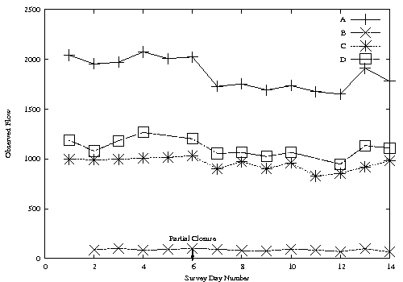

Figure 2: Flow versus survey day sites A-D
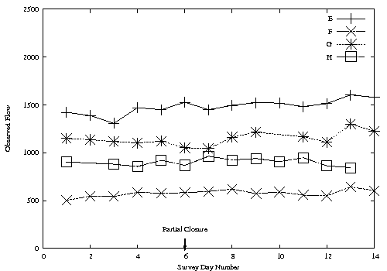
Figure 3: Flow versus survey day sites E-H
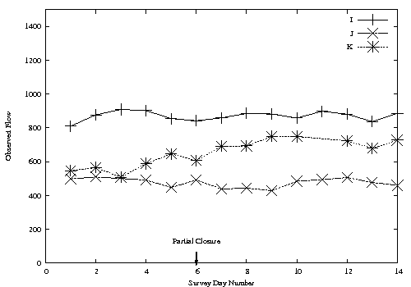
Figure 4: Flow versus survey day sites I-K
Looking at these figures, it is hard to see if the average effect of the closure is to increase or decrease flow. For some sites, for example A and D, an obvious flow decrease occurs. However, for others (for example K) an increase seems to occur. To answer the question “do flows, on average, increase or decrease as a result of the closure” a method must be found of comparing the flows between different sites. This can be done by considering the flows at each site normalised so the flow at each site averaged across all days has a mean of 1. That is
$F(i,s)=n(s)f(i,s)/{\sum_{i}{f(i,s)}}$,
where n(s) is the number of days of data available for site s, f(I,s) is the flow at site s on day I and F(I,s) is the normalised flow at site s on day I. After this normalisation then flow data can be compared between sites. If F_{c} is the mean normalised flow across all sites on days when the closure is in place and F_{o} is the mean normalised flow on days when the closure is not in place then, from the data F_{c}= 1.0060 and F_{o}=0.9976 (there appears to be marginally more traffic on these sites when the closure is in place. A t-test gives a p-value of 0.63 indicating that the t-test cannot tell whether these means are different with statistical significance. In other words, it cannot be told from the data whether the mean flow level rose as a result of the change or not.
An explanation for this is that some of the survey sites were chosen because they would be directly affected by the closure and some were chosen because they would be obvious reroutings. Sites A, C and D are sites where a reduction in flow would be expected and sites F, G and K are sites which might be expected to have more traffic due to rerouting. This suggests the following GLM,
$E[F]=β_{0}+β_{1}I_{c}+β_{2}I_{r}$,
where F is the normalised flow at a given site on a given day, I_{c} is an indicator variable which is 1 if the site is A, C or D and the closure is in place on this day and 0 otherwise and I_{r} is an indicator variable which is 1 if the site is F, G or K and the closure is in place on this day and 0 otherwise. Fitting this model gives the reassuring answers in Table 1 below. This shows that, as expected, the rerouting sites have increased traffic when the closure is in place and the directly affected sites have decreased traffic. The parameter values show that the parameters modelled all have a high degree of statistical significance. This is, of course, no real surprise. The low R² value shows that there is a huge amount of variability in the data that cannot be explained by this model (again, this is absolutely to be expected).
Parameter | β₀ | β₁ | β₂ | R² | R_{a}² | p-value
Estimate | 1.004 (0.1%) | -0.063 (0.1%) | 0.037 (0.5%) | 0.123 | 0.111 | 8.3 x 10⁻⁵
Table 1: GLM to fit flows across sites.
It could be considered that an improvement of this would be to change the sites considered as potential rerouting sites and sites considered as potential flow reduction sites to maximise the R² value. However, this procedure would invalidate the p-value and would, generally be statistically suspect (since it is introducing unmodelled degrees of freedom – the sites which form the sets being degrees of freedom in the model which are not accounted for in calculating the p-value or the value of R_{a}²).
5. Data Pre-Processing
To proceed further with the analysis it was necessary to consider pairs of sites and the flow and travel times between these site pairs. Pairs of sites of interest were chosen by consideration of likely routes through the city and also by examination of the data itself.
It is necessary to perform considerable pre-processing on the data before analysis can be performed on site pairs. In specific, a large amount of processing is necessary in order to consider the travel times and flows which genuinely travel between pairs of sites. While this may seem trivial, in fact the problem is made complex by the fact that only partial licence plates are recorded. This leads to the well-known false match problem in licence plates. A number of approaches have been tried to solve this problem: Hauer (1979), Maher (1985), Watling and Maher (1988) and Watling and Maher (1992). In this paper a maximum likelihood estimator is used which is taken from Watling (1994). This fits a model to the site pairs and uses this model to estimate the flow between the pair and the travel time between them based on assumptions about the nature of the input traffic. While the details of the method are not included here, the reader should bear in mind that this pre-processing has taken place and that the flows and travel times used in the following section are, themselves, the output of a model rather than raw data observations.
A second issue is the problem of how journeys that actually take place may not be recorded. Consider the flow between two site: this may be reduced because the number of vehicles travelling between the sites goes down. However, it may be reduced in a second way. If the travel time between the sites goes up, the number of vehicles seen to travel between them will go down simply because the end of some journeys will be missed. If the question asked is how many vehicles are seen at site A between 8:00 and 9:00 and continue on to site B then the wrong answer would be obtained if the survey at site B stops too soon. Worse, this may become a systematic bias if the travel time between A and B increases then the number of missed vehicles goes down. This effect is corrected for by “trimming” the data by removing the final half hour of data from the first site of a site pair. None of the sites pairs considered were so far apart that the journey time would reach half an hour.
Finally, for every site the data was then normalised in the obvious way (subtract the mean and divide by standard deviation) so that flows and travel times for each site had a zero mean and a unit variance. This allows travel time and flow data to be compared between sites. A cautionary note is that this may introduce minor biases for those sites with missing days of data.
6. Modelling Flow and Travel Time
After the pre-processing described in section five, a GLM as described in section three was fitted to flow and travel time data. The aim of the model was to capture the “It’ll be alright by Friday” effect, that is an initial transient response to the closure followed by a return to normal effect. The model fitted was:
$E[y]=β_{0}+β_{1}I_{c}+β_{2}D$,
where y represents either flow or travel time I_{c} is an indicator variable which is 1 if the closure is in place and 0 otherwise and D is a variable indicating the number of days since the closure occurred (not including weekends) or 0 if the closure is not in place. For clarity, the variable D has the value 1 on the 3rd July, 2 on the 4th July and 10 on the last day surveyed, the 16th July.
If the model is successful then the parameters β₁ and β₂ will have opposite signs. The models are fitted for those site pairs considered most relevant. Table 2 shows the model fitted for normalised travel times and Table 3 shows the model fitted for normalised flows. Each row in these tables indicates a separately fitted model with the data for that site pair. The figures in brackets are the significance of parameters listed with (low) indicating parameters with a significance level worse than 10%. The shaded lines are models with at least two significant parameters.
Pair | β₀ | β₁ | β₂ | R² | R_{a}² | p-value
A -- D | -0.58 (5%) | -0.32 (low) | 0.24 (0.1%) | 0.74 | 0.68 | 0.002
A -- J | 0.65 (low) | -0.54 (low) | -0.10 (low) | 0.35 | 0.22 | 0.12
C -- A | -0.67 (1%) | 1.9 (0.1%) | -0.093 (10%) | 0.76 | 0.71 | 0.00040
D -- I | 0.21 (low) | -1.11 (10%) | 0.11 (low) | 0.31 | 0.15 | 0.19
E -- A | -0.37 (low) | 1.65 (1%) | -0.14 (5%) | 0.55 | 0.47 | 0.012
E -- F | 0.51 (low) | -0.92 (low) | -0.02 (low) | 0.26 | 0.12 | 0.19
E -- K | 0.59 (low) | -0.49 (low) | -0.13 (low) | 0.41 | 0.30 | 0.069
F -- A | -0.44 (low) | 1.41 (5%) | -0.08 (low) | 0.40 | 0.30 | 0.058
F -- G | 0.56 (low) | -1.11 (10%) | -0.016 (low) | 0.38 | 0.25 | 0.09
G -- C | -0.78 (5%) | 1.06 (5%) | -0.094 (low) | 0.65 | 0.58 | 0.0054
H -- I | -0.53 (low) | -0.25 (low) | 0.20 (5%) | 0.49 | 0.39 | 0.034
Table 2: GLM fitting for travel times and significance levels for parameters.

Pair | β₀ | β₁ | β₂ | R² | R_{a}² | p-value
A -- D | 0.73 (5%) | -1.50 (1%) | 0.0062 (low) | 0.60 | 0.51 | 0.017
A -- J | 0.74 (5%) | -1.49 (1%) | 0.017 (low) | 0.55 | 0.47 | 0.018
C -- A | 0.68 (10%) | -0.51 (low) | 0.067 (10%) | 0.47 | 0.38 | 0.030
D -- I | 0.21 (low) | -1.45 (5%) | 0.17 (5%) | 0.57 | 0.47 | 0.023
E -- A | -0.041 (low) | -0.047 (low) | 0.020 (low) | 0.0046 | -0.18 | 0.97
E -- F | -0.30 (low) | -0.43 (low) | 0.17 (10%) | 0.30 | 0.17 | 0.14
E -- K | -0.65 (5%) | 1.48 (1%) | -0.012(low) | 0.56 | 0.48 | 0.016
F -- A | 0.33 (low) | 0.03 (low) | -0.11(low) | 0.17 | 0.017 | 0.36
F -- G | -0.20 (low) | 0.35 (low) | 0.013 (low) | 0.045 | -0.15 | 0.79
G -- C | 0.27 (low) | -1.35 (5%) | 0.11 (low) | 0.37 | 0.24 | 0.10
H -- I | -0.16 (low) | 1.44 (1%) | -0.19 (5%) | 0.60 | 0.51 | 0.02
Table 3: GLM fitting for flows and significance levels for parameters.
Note that extreme caution should be applied when trying to interpret these results. When so many tests are run it is inevitable that some parameters will be seen as statistically significant.
Only those models with two significant parameters are discussed here. In looking at the travel times only three pairs of sites meet this criterion, C—A, E—A and G—C. In many ways it is not at all a surprise that C—A and E—A suffer increased travel times as a result of the intervention. These site pairs are those that are the most significantly affected by the closure since both lead directly into the partially closed lane A. The site pair G—C feeds directly into C—A and a slow down in travel from C—A could well be expected to cause tail backs affecting travel from G—C. All three pairs show an increased travel time after the closure that gradually decreases in the following days (though in the G—C pair this decrease parameter is not statistically significant). These site pairs also show reasonable R² values (it would not be expected that all the variation in travel times was explained by such a simple model) and low p-values.
In considering flows, six site pairs have two significant parameters (none have three). It is perhaps surprising that the site pairs E—A and G—C which showed clear effects on travel time do not show clear effects on flow. Indeed the site pair C—A which showed a clear effect on travel time shows only the weakest level of significance.
Site pairs A—D, A—J and D—I all show a reduction in flow as a result of the closure. This would be expected as these sites are all directly after the closure and it would be surprising if they were not affected by reduced flow as a result of reduced capacity on their main feeder road. What is more interesting is that all three are exhibiting “return to normal” effects (unfortunately, only the pair D—I shows this with statistical significance) perhaps indicating that the traffic is adapting slightly and more flow is able to get through. Site pair C—A shows an initial decrease in flow (as might be expected) and a return to normal effect which is statistically significant at the 10% level.
Site pairs E—K and H—I are both possible reroutings as a result of the closure (E—K is a rerouting for traffic originally from E—A and going the other way around the inner ring road and H—I is a rerouting for traffic originally from E—A and swapping to enter the city further along the outer ring road). Of course it is purely speculation that rerouting is the reason for the increase in traffic. It could be that increased flows are the result of traffic flowing more smoothly in those parts of the city either because of the partial closure reducing competing flows or for some unconnected reason.
Note that a number of more sophisticated models and different fall-off speeds for D were considered. However, given the already poor fit then adding further parameters to the model did not seem well justified. The fit to the models was generally better with D measured as stated than with other obvious variants (for example if D did include weekends or if 1/D was used instead). Obviously this linear fit with D is a simple approximation and would certainly not be valid in a longer term (for a start it would predict flows becoming negative or extremely large as time went on).
In a few cases the strict linear fit actually predicts a return “beyond” the original position for the largest value of D considered (D = 10). This occurs with travel times at A—D and with flows at C—A, D—I and H—I. However, this is almost certainly a product of the crudeness of a linear model to fit the data rather than genuinely indicating an effect that was seen on street.
It is interesting that for those site pairs that did not have a capacity reduction (e.g. those not including site A) traditional models of cost-flow are not well followed by this data. For example site pair G—C has increased travel time without a statistically significant increase or decrease in flow. Site pair H—I has a statistically significant increase in flow without a statistically significant increase in travel time. It is hard to draw any firm conclusions from this but it is interesting that the expected correlation between increased flows and increased travel times does not seem to be present here.
7. Conclusions
The data examined show a number of effects that result from a capacity reducing incident on a road network. While none of these effects are, in themselves, unexpected, it is good to have experimental confirmation of certain rules of thumb. Firstly, no clear effect on flow was seen over all sites surveyed as a result of the closure. In this case, therefore, no clear reduction in flow on the network as a whole was observed. However, when sites were grouped into those where a reduction in flow was expected (due to capacity restraints) and those where an increase in flow was expected (due to rerouting) then the fit to the model was good.
In particular the “it’ll be alright by Friday” effect of a gradual return to normal following an intervention seemed to hold empirically. Both travel times and flow levels showed the phenomenon of an initial effect followed by a return towards the original condition as time continues indicating that, in some way, travellers “adapt” to a closure even in the relatively short time scale (the survey considered only looked at a maximum time which was ten week days into the closure).
To obtain these results considerable pre-processing needed to be performed on the data and the conclusions rest on a single survey of one incident. It would be extremely useful to have more and better data to confirm or deny these conclusions and to learn more about how road traffic responds to capacity reducing incidents.

Bibliography
Batley, R. P. and Clegg, R. G. 2001: Driver Route and Departure Time Choices: The Evidence and the Models. Presented at Universities Transport Studies Group 2001 and available online at www.richardclegg.org/pubs/utsg2001.doc
Clegg, R. G., 2003. A Freely Available Data Set for Modelling Day-to-Day Route Choice. Presented at Universities Transport Studies Group 2003 and available online at:
www.richardclegg.org/pubs/rgc_utsg2003.doc
Clegg, R. G., 2004. The Statistics of Dynamic Networks, PhD Thesis, Department of Mathematics, University of York. Available online at: http://www.richardclegg.org/pubs/thesis.pdf
Clegg, R. G., 2005. An Empirical Study of Day-to-Day Variability in Driver Travel Behaviour. Presented at Universities Transport Studies Group 2005 and available online at:
http://www.richardclegg.org/pubs/rgc_utsg2005.doc
Hauer, E. 1979. Correction of licence plate surveys for spurious matches, Transportation Research A 13A pp 71—78.
Hoel, P. G. 1984. Introduction to Mathematical Statistics (Fifth Edition) Wiley.
Maher, M. J. 1985. The analysis of partial registration-plate data, Traffic Engineering and Control 26 (10) pp 495—497.
Mendenhall, W. and Sincich, J. 2000. Statistics for Engineering and the Sciences. Prentice-Hall (Englewood Cliffs, N.J.)
Watling, D. P. and Maher, M. J. 1988. A graphical procedure for analysing partial registration-plate data, Traffic Engineering and Control 29 (10) pp515—519.
Watling, D. P. and Maher, M. J. 1992. A statistical procedure for estimating a mean origin-destination matrix from a partial registration plate survey, Transportation Research B 26B(3) pp171—193.
Watling, D. P. 1994: Maximum likelihood estimation of an origin-destination matrix from a partial registration plate survey, Transportation Research B 28B(3) pp289—314

