AN EMPIRICAL STUDY OF DAY-TO-DAY VARIABILITY IN DRIVER TRAVEL BEHAVIOUR
Dr Richard G. Clegg (richard@richardclegg.org)
Research Assistant
Department of Mathematics, University of York, Heslington YO10 5DD

Abstract
This paper analyses variability in daily travel behaviour observed in morning peak commuters in the town of York (UK). Commuters were monitored using manual licence plate surveys. Two surveys took place which both concentrated on important planned road closures in the city of York. Here, the data is examined by comparing different surveyed days at the same sites. Even at the same survey site, the individual vehicles in a given rush hour change greatly as day follows day. A general linear model is fitted to the data that shows a number of interesting effects.
In particular, a marked day of the week effect is shown. This can be thought of crudely as the “See you next Wednesday” effect – the fleet of vehicles driving in a particular rush hour is much more consistent if the two days compared are both the same day of the week. The data collection and analysis is described in detail in Clegg (2004, chapter 5). The data is freely available from the web on: gridlock.york.ac.uk/route.

1. Introduction
This paper describes and analyses data that were collected as part of an EPSRC funded project that was held jointly at the Universities of York and Leeds. The aim of the project was to collect and analyse data to study driver route choice. This data was also described in Clegg (2003) and Clegg(2004, chapter 5). More information on the material covered here and all the data used can be found on the web at: gridlock.york.ac.uk/route/. In specific the data is analysed here with respect to recurrence rates, that is to say, the number of vehicles seen on separate survey days.
Code to perform matching of licence plates based upon a Maximum Likelihood Estimator approach was written by Stephen Clark (Leeds City Council) and David Watling (Institute for Transport Studies, University of Leeds). Their work and many useful discussions were extremely valuable in the research described here. The assistance of Stuart Dalgleish (York City Council) was invaluable in the data collection described in this paper and without this then the research described here could never have been completed.
This paper describes a two studies carried out in the city of York. Lendal Bridge is part of the city's inner ring road. In the September 2000 the bridge was close for routine maintenance work. Unfortunately this closure was also affected by the fuel crisis (the protest movement which caused a temporary interruption to fuel supplies in Britain and therefore to a reduction in the number of drivers). Fishergate is a part of the city’s inner ring road. In the July 2001 this was partially closed in one direction for necessary sewer maintenance. The aim of the project was to collect a data set that could be used to investigate the effects of this closure. Before and during surveys were taken on a number of sites and licence plate data was collected. In this paper the before and during surveys are analysed mainly with respect to matches between days. Because of the interruptions to the Lendal Bridge survey from unusual effects the majority of the analysis is done on the Fishergate data.

2. Background
It is widely accepted that a rush hour is not composed of the same drivers travelling to the same destination day after day. The term recurrence rate is defined as the percentage of vehicles observed in some time period T₁=(s₁,e₁) (that is a period beginning at s₁ and ending at e₁) who are also observed during some subsequent time period T₂=(s₂,e₂). Note that the recurrence rate will depend upon several factors. Even if the observations made are assumed to be perfect, this recurrence rate will depend on the exact choice of the time periods. If the rush hour were identical every day and T₁ and T₂ were the same period on subsequent days then the recurrence rate would be one hundred percent. Of course it is clear that this idealisation is far from true. In reality the recurrence rate will be less than this. It is also obvious that the specific choice of T₁ and T₂ is critical. For example changing T₂ to T₂’=(s₂’,e₂’) where s₂’<s₂ and e₂’>e₂ means that the recurrence rate will always be the same or larger (because a superset of vehicles is observed in T₂’). The idea of this paper is to gain insight into the factors which affect this recurrence rate in real traffic. If a vehicle is observed in period T₁ but not in T₂ this might be explained by a number of response mechanisms. The driver may have changed route, changed departure time, changed destination, changed mode or decided not to make the journey at all.
Batley and Clegg (2001) and Clegg (2004, chapter 3) review concerning surveys of driver route and departure time choice and these reviews touch on the idea of ambient variability in the driver pool. A review from the point of view of Global Positioning System (GPS) data is given by Pendyala (2003) and the author analyses several small data sets of between sixteen and thirty-two individuals, concluding that, “The percentage of individuals in each sample who exhibit the same characteristic across all days...is extremely small... [often] zero.” Huff and Hanson (1986, 1990) investigated the Uppsala Household Travel Survey, a data collection exercise undertaken in Sweden in the 1980s. An important conclusion of their work is that “observations taken for a single day in the travel history of an individual are not likely to be representative of the range of daily travel patterns exhibited by that person over a more extended time period, and we are led to reject the view that travel is highly routinized in the restricted sense that every weekday is assumed to look much like every other weekday" (Huff and Hanson 1986, page 108. A report on GPS data from single vehicles from one hundred households (216 drivers) over a one-week period is given by Jan et al (2000). They report: “the path chosen on a trip most often differs considerably from the shortest time path across the network" (Jan et al 2000, page 1) and also that “travelers habitually follow the same path for the same trip" (Jan et al 2000, page 12).
Bonsall et al. (1984) report on the collection of a large number of licence plates from road-side surveys undertaken in Leeds. An interesting outcome of their report was the unreliability of number plates collected in this way. They report that, when looking at the number of matches in is necessary to “assume a 15% increase in the number of matches” (page 387) due to missed matches from incorrectly recorded data. They give the following table of matches (where % match is the recurrence rate as previously defined):

Day 1 Time period (beginning time) | % match in same period day 2 | % match in same or adjacent period day 2 | % match in any time period on day 2
7:15 | 23 | 36 | 35
7:30 | 24 | 26 | 30
7:45 | 15 | 23 | 28
8:00 | 19 | 28 | 32
8:15 | 24 | 38 | 45
8:30 | 19 | 27 | 38
8:45 | 11 | 21 | 23
9:00 | 9 | 15 | 22
9:15 | 6 | 10 | 8
9:30 | 5 | 8 | 0
Table 1: From Bonsall et al. (1984): Match rates at different times within the peak. All figures should be increased by 10-20% to allow for misreading.
In summary, all these results lead to the same conclusion. The rush hour is highly variable from day-to-day. This paper seeks to provide further insight into this process and to model the factors that affect the recurrence rate using two surveys which took place in the city of York.

3. York Surveys and Initial Data Description
The timing of the surveys was chosen with several considerations in mind:
- It was considered important to get a good estimate of the ambient variability between days in the city and also the trends in traffic patterns between weeks.
- It was considered important to monitor the transient response in the days immediately following the closure.
- It was thought of as desirable to get some estimate of the longer-term response to the closure (whether the traffic had time to form a new equilibrium and how long this took to establish).
- It was not considered appropriate to monitor weekends. While it was recognised that traffic differs considerably between weekdays, it was considered that this variation was extremely minor compared with the variation in travel patterns between a typical weekday and a Saturday or a Sunday.

The geographical location of surveys was chosen with the following considerations:
- It was considered important to get a good survey of the areas directly affected by the closure.
- It was considered important to monitor those sites that were most likely to have knock on congestion from the closure.
- It was considered important to try to monitor potential rerouting locations.
It was considered important to monitor points nearer to the possible origin and destination of the drivers affected.
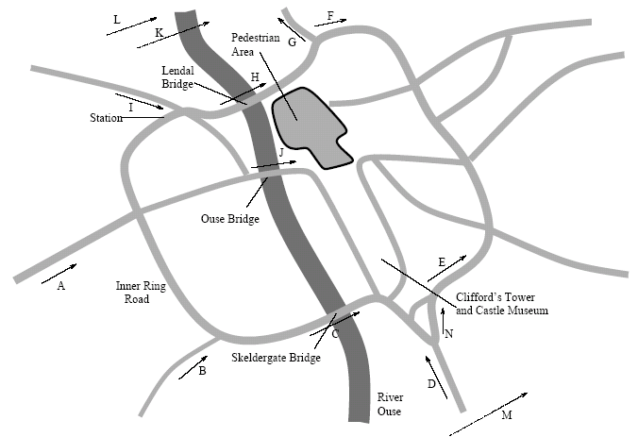
Figure 1: York Lendal Bridge Survey showing survey sites.
Figure 1 shows the survey sites for the Lendal Bridge survey. All sites were surveys in the direction of the arrows shown. The aim was to monitor traffic moving across the river from west to east (the bridge was closed in both directions but insufficient surveyors were available to monitor both). During the closure surveyors from site H were redeployed to site N. At all sites the surveys were from 8:00am to 9:00 am. The days surveyed in the Lendal Survey were as follows:
- Two early before days 27th and 28th June 2000.
- Three before survey days 6th, 7th and 8th Sept 2000.
- Two during days affected by fuel crisis 11th and 13th Sept 2000.
- Two during days 27th Sept and 18th Oct 2000.

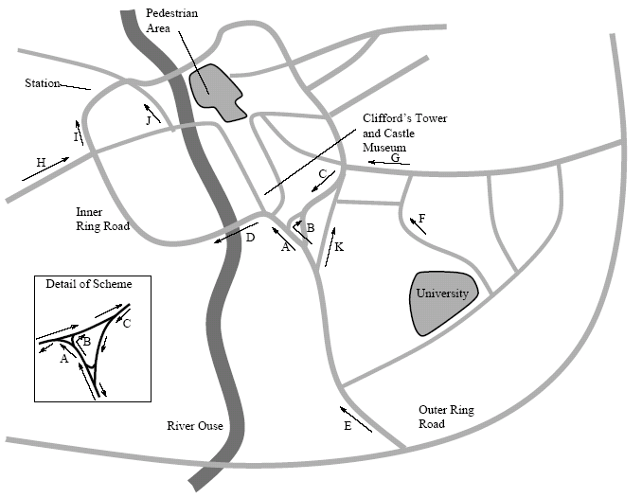
Figure 2: Fishergate Survey showing survey sites.

Figure 2 shows the survey sites used for the Fishergate Survey. All sites are monitored only in the direction of the arrows given. This survey was based around works to repair a collapsed sewer at site A. The repair work involved a partial closure of site A, essentially one lane being removed from the road.
The closure was originally scheduled to last only two weeks and therefore the plan was to survey for one week before, one week during and one week after the closure. However, the closure was extended to four weeks and therefore no true after survey data is available. A possible exception is the 13th of July when the closure was suspended for one day to allow for the increase in traffic due to a major horseracing event that weekend (the extra traffic due to the race-goers is thought not to have had a great effect on traffic during the morning peak). The days surveyed were as followed:
- 25th, 26th, 27th, 28th, 29th June and 2nd July – before surveys.
- 3rd, 4th, 5th, 6th, 11th, 12th July – during survey.
- 13th July – temporary removal of roadworks (could be seen as after).
- 16th July – during survey (roadworks back in place).
For the Fishergate survey, for most sites, the traffic was monitored at most sites from 7:45 to 9:15. This was in order to catch all of the rush hour traffic and a quarter of an hour window either side. However, at selected sites, this window was adjusted to monitor from 8:00 to 9:30. This happened at those sites that would be reached last on a journey (for example, in Figure 1 site J would always be reached after site A). This was decided since the travel time between some pairs of sites was of the order of half an hour. Without such an offset some of the survey time would otherwise be wasted since the earliest (or latest) parts of the data could not be expected to match with data at any other site. The sites that were surveyed from 8:00 to 9:30 were sites A, I and J.
Timing on both surveys was performed by asking the surveyors to record the time at approximately five minute intervals. Surveyors were supplied with synchronised watches at the beginning of the surveys. The times for data between each time stamp are interpolated so, for example, if there are ten plates between a time stamp at 8:10 and one at 8:19 they will be split so that one plate is seen in each minute. Because of this interpolation and possible rounding of the time, the times recorded can only be assumed to be accurate to within five minutes, however, it is hoped that it is accurate to a much greater resolution than this.
The surveys were mainly undertaken by audio tape (that is, surveyors recording licence plates onto audio tape which were later transcribed). A phonetic alphabet was used to minimise the likelihood of confusion between similar sounding letters such as N and M. However, the possibility of recording or transcription errors should be taken seriously.

4. Analysis Techniques Used
The main statistical tool used in this work is the General Linear Model (GLM). The GLM assumes that a variable y is dependent on parameters x₁,x₂…x_{k} in such a way that
$$y=β_{0}+\sum{β_{i}x_{i}}+ε,$$
where the ε are assumed to be independent and identically distributed with a normal distribution mean zero and with variance independent of the x_{i}. Note that the x_{i} need not be independent. So, for example, it might be assumed that x₂=x₁². Often the x_{i} are indicator variables, that is they are variables which are 0 if a certain condition is not met and 1 if that condition is met. This allows the introduction of Boolean variables such as “road has been closed” or “day is a Wednesday” into the model. More details of GLM can be found in Mendenhall and Sincich (2000). The parameters β_{I} are chosen in such a way as to minimise the sum of the errors. The model can be fitted computationally. The goodness of fit is assessed using the R² statistic which is given by
$R^{2}=1−\frac{\text{SSE}}{{\text{SS}}_{\text{yy}}}=\frac{\sum{(y−{\hat{y}}_{i})^{2}}}{\sum{(y−\bar{y})^{2}}}$,
where SSE is the sum of the squares of the errors, SS_{yy} is the variance of y, y_{i} is a measured value,${\hat{y}}_{i}$is the estimate produced by the model for y_{i}, and $\bar{y}$is the sample mean for y. The value of R² is between 0 and 1 with 0 indicating no predictive power on the part of the model and 1 indicating the model passes exactly through every data point. Of course and model can be made arbitrarily close to 1 by adding more and more parameters. Hence, an alternative statistic R²_{a} is used and this is given by,
$R_{a}^{2}=1−\frac{n−1}{n−(k+1)}(1−R^{2})$,
where n is the sample size and k is the number of parameters used. It can be easily seen that R²_{a} is always less than R². The value of R² can be used to test hypothesis. Assume the above model and the two hypotheses,
$H_{0}:β_{1}=β_{2}=\text{.}\text{.}\text{.}=β_{k}=0$
H_{a}: there exists some j>0 such that β_{j} ≠0,
where H₀ is the null hypothesis. The F statistic is given by
$F=\frac{{R^{2}}/k}{(1−R^{2})(n−(k+1))}$ .
Under the previously listed assumptions for the GLM then the hypothesis H₀ can be rejected with confidence (1-α) if F > F_{α} where F_{α} is a function of α, v₁ = k and v₂=(n – (k+1)) and can be either looked up on tables or calculated using a computer. The p-value is the value of α where F = F_{α} for the given model and this is the borderline between accepting and rejecting a model with the given confidence. For example, if the p-value is less than 0.05 we can say that the model can be accepted at a 95% confidence level. This can also be phrased as significant at the 5% level.

5. Matching Data Between Sites
The data collected at the sites is only partial plate data – that is only part of the licence plate is collected. The licence plates are all old style UK plates (with the exception of a few foreign plates) and only the digits (usually three) and single year letter are collected. Unfortunately, this leads to a problem with false matches – that is different vehicles being confused because, by chance, they have the same partial plate (e.g. A123ABC and A123XYZ would both be observed as A123). It may seem at first that this problem would be statistically insignificant. The probability of this happening for any pair of vehicles is extremely low (Clegg 2004) estimates it as 7.26x10⁻⁷. However, given the number of pairs of vehicles in a data set (for the data used here this can be a million pairs of vehicles or more) the number of false matches can be large. This is something of a classic problem in transport engineering and for more details on possible solutions see Hauer (1979), Maher(1985), Watling and Maher(1988 and 1992) and Watling (1996). Because the matches in the next section are between days, time information cannot be used and only the simplest techniques are possible. For this paper, a simple probabilistic correction is applied similar to the approach in Hauer (1979). The number of matches is corrected by making the following assumptions. Given two data sets with n₁ and n₂ observations in each there is a probability p that any pair is a false match. If t is the number of true matches f is the number of false matches and m is the number of matches observed in the data then an estimator is given by
$$\begin{aligned}\hat{t}=m−\hat{f}=m−(n_{1}n_{2}−t)p \\ \hat{t}=\frac{m−n_{1}n_{2}p}{1−p}\text{.}\end{aligned}$$
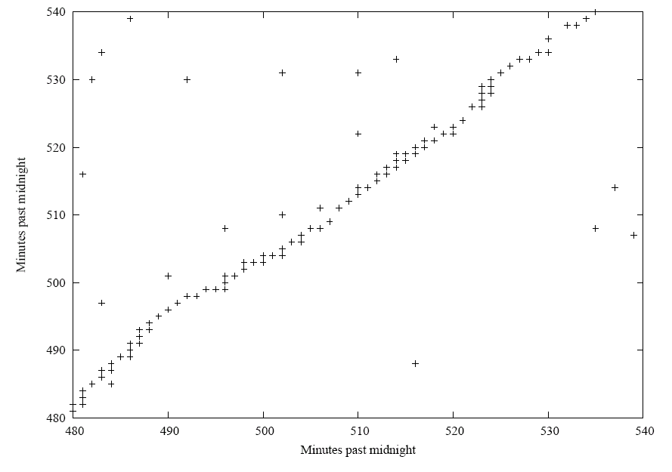
Figure 3: Matches between Lendal Bridge sites I and J on 28/6/00.
An insight into the nature of the data can be gained by plotting the matches including false matches. In figure 3, a point is plotted every time a match is found between two data points. The main diagonal shows what are likely to be true matches in the data, vehicles travelling between sites I and J on the given day. As can be seen from figure 1, this is a reasonable journey and a number of genuine matches are expected here. The points off the diagonal are likely to be false matches. An insight into the scale of the false matching problem is given by the next figure.
As can be seen from figure 1, a journey between Lendal Bridge sites L and M is not a likely route in rush hour. Indeed, it is unlikely in the extreme that any vehicles at all made this journey and it is likely that all the points on the graph represent false matches. The large number of false matches here is explained by the fact that both sites were heavily trafficked sites on the outer ring-road and hence the number of vehicles observed at each site is large.
Figure 5 shows matches at Lendal Bridge site M between 6/9/00 and 7/9/00. This is typical of the type of match that will be considered in the rest of this paper. While the diagonal is not as strong as in figure 3, there is still a notable diagonal to the matches. This is likely to be drivers who travel at the same time on both days.
It should be noted that no assumptions have been made about the accuracy of the data. All reasonable efforts were taken to ensure that the surveys were accurate but it is certain that some errors will be present and the actual matching rate should be higher than that recorded.

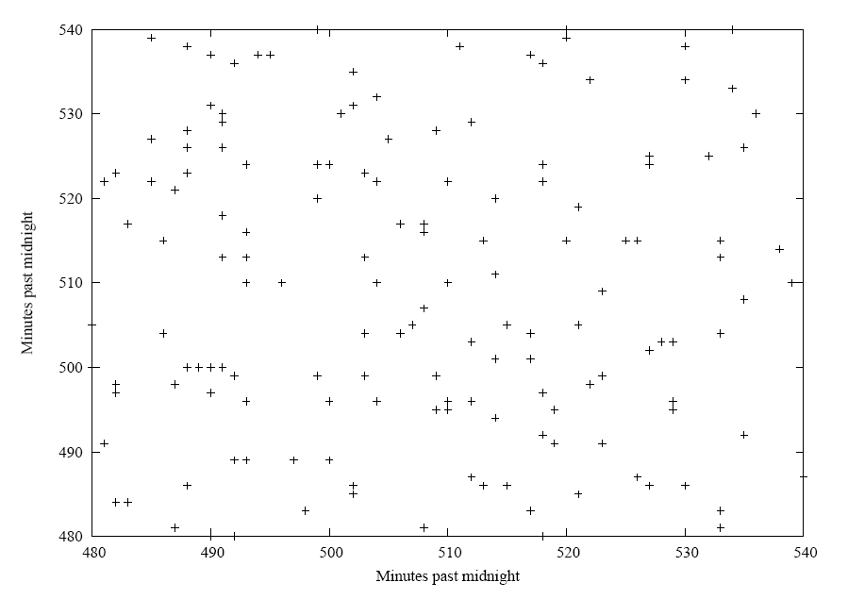
Figure 4: Matches between Lendal Bridge sites L and M on 28/6/00
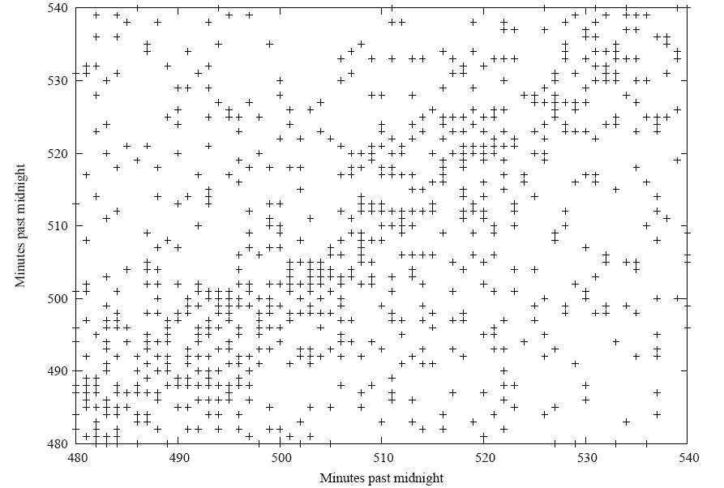
Figure 5: Matches between vehicle at Lendal Bridge site M matched between 6/9/00 and 7/9/00.

6. Recurrence Rates Between Days
Tables 2, 3 and 4 show the recurrence rate between days. It should be noted that due to the false match problem, the recurrence rate cannot be measured only estimated. In the tables, there are two figures in every cell. The first figure in row I column j is the number of pairs which match divided by the number of observations in the data set of row I and expressed as a percentage. The second figure (in brackets) is the figure assuming a probabilistic correction as described in the previous correction. It is this second figure which will be considered in the text. The diagonal (in bold) is the match of a data set against itself and the corrected figure here should be approximately 100%. In table 2, the shaded columns show those days that were affected by the fuel crisis.
Inspection of these tables shows a number of striking features. Firstly, it is clear that the data falls of the further it is from the diagonal. This hints at the idea that (as might be expected) the recurrence rate reduces the further apart two days are.

 | 27/6/00 | 28/6/00 | 6/9/00 | 7/9/00 | 8/9/00
27/6/00 | 107.6 (99.7) | 47.3 (39.0) | 24.3 (17.8) | 24.6 (18.1) | 25.2 (18.8)
28/6/00 | 44.5 (36.7) | 109.8 (101.5) | 25.3 (18.7) | 25.1 (18.6) | 22.0 (15.6)
6/9/00 | 29.1 (21.3) | 32.2 (23.9) | 105.1 (98.6) | 45.4 (38.9) | 39.9 (33.6)
7/9/00 | 29.6 (21.8) | 32.1 (23.7) | 45.6 (39.0) | 107.9 (101.4) | 43.2 (36.9)
8/9/00 | 31.0 (23.2) | 28.8 (20.5) | 41.1 (34.5) | 44.3 (37.8) | 105.5 (99.2)
11/9/00 | 29.7 (21.9) | 29.7 (21.4) | 37.4 (30.8) | 37.9 (31.4) | 37.2 (30.9)
13/9/00 | 26.8 (19.0) | 30.6 (22.3) | 34.0 (27.5) | 33.6 (27.1) | 34.3 (27.9)
27/9/00 | 31.4 (23.6) | 32.7 (24.4) | 34.8 (28.2) | 32.5 (26.0) | 32.4 (26.0)
18/10/00 | 25.9 (18.1) | 30.7 (22.3) | 29.1 (22.6) | 30.9 (24.4) | 29.4 (23.0)
 | 11/9/00 | 13/9/00 | 27/9/00 | 18/10/00
27/6/00 | 25.5 (18.8) | 20.2 (14.3) | 26.8 (20.1) | 22.2 (15.5)
28/6/00 | 23.9 (17.2) | 21.7 (15.8) | 26.2 (19.6) | 24.7 (18.0)
6/9/00 | 38.3 (31.6) | 30.7 (24.8) | 35.5 (28.8) | 29.9 (23.2)
7/9/00 | 39.1 (32.4) | 30.5 (24.6) | 33.3 (26.6) | 31.8 (25.1)
8/9/00 | 39.3 (32.6) | 31.9 (26.0) | 34.0 (27.3) | 31.0 (24.3)
11/9/00 | 108.4 (101.6) | 36.0 (30.1) | 37.5 (30.8) | 30.3 (23.6)
13/9/00 | 40.9 (34.2) | 110.0 (104.1) | 34.6 (27.9) | 32.8 (26.1)
27/9/00 | 37.6 (30.9) | 30.6 (24.7) | 106.7 (100.0) | 39.2 (32.5)
18/10/00 | 30.3 (23.6) | 28.9 (23.0) | 39.0 (32.3) | 104.1 (97.4)
Table 2: Lendal Bridge Site L Between Day Matches 8:00-9:00

Table 2 shows a number of striking features. First, the recurrence rates are notably low. The rate never gets as high as 40%. For the data sets that are months apart, the recurrence rate has fallen to less than 20%. It seems clear from this data that the recurrence rate between days undergoes a rapid fall off with time and also that the fuel crisis days show lower than normal recurrence rates.

Table 3 shows the data at Fishergate site A on all days. Firstly, again it can be seen that the further from the diagonal (the further apart two days are) the lower the recurrence rate. Another feature that seems to stand out is that the recurrence rate increases again if two days are the same day of the week (e.g. 25/6/01 and 2/7/01 or 26/6/01 and 3/7/01). This hypothesis will be investigated statistically in the next section. After as short a period as two weeks the recurrence rate seems to be down below 25%. Of course, as mentioned, errors may be present in the data and the genuine recurrence rate should be higher than this.

Table 4 shows similar data to table 2 but with a more generous measure of the recurrence rate. The recurrence rate is measured with traffic seen from 8:20-8:40 on the first day matched against traffic seen at any surveyed time on the second day. Naturally, this will produce a higher matching rate than seen in table 3. However, the same fall-off can still be seen and the same day of the week dependence.

7. Model Fitting for Recurrence Rates
Investigation of the data shown in tables 2,3 and 4 and similar data from other survey sites suggests the following GLM,
$$E[R]=β_{0}+β_{1}\left|d\right|+β_{2}I_{w}+β_{3}I_{d},$$
where R is the recurrence rate, d is the number of days separating the two surveyed days (not including weekends), I_{w} is an indicator variable which is 1 if the two survey days are in different weeks and I_{d} is an indicator variable which is 1 if the two survey days are on the same day of the week. A similar model was tried with |d| including weekend days and the fit was not as good.

 | 25/6/01 | 26/6/01 | 27/6/01 | 28/6/01 | 29/6/01
25/6/01 | 116.8 (105.5) | 46.1 (35.4) | 45.5 (34.5) | 46.1 (34.7) | 43.4 (32.3)
26/6/01 | 48.4 (37.1) | 114.9 (104.2) | 52.1 (41.1) | 53.4 (42.0) | 44.3 (33.2)
27/6/01 | 46.7 (35.5) | 51.1 (40.3) | 118.6 (107.6) | 52.8 (41.4) | 45.7 (34.6)
28/6/01 | 45.5 (34.2) | 50.3 (39.5) | 50.8 (39.8) | 118.3 (106.9) | 47.1 (35.9)
29/6/01 | 43.8 (32.5) | 42.7 (31.9) | 44.9 (33.9) | 48.0 (36.6) | 115.9 (104.8)
2/7/01 | 48.0 (36.7) | 44.0 (33.3) | 44.0 (33.0) | 45.9 (34.6) | 43.3 (32.2)
3/7/01 | 44.1 (32.9) | 49.9 (39.1) | 46.6 (35.6) | 49.1 (37.7) | 43.3 (32.2)
4/7/01 | 40.8 (29.6) | 42.5 (31.8) | 49.7 (38.7) | 46.5 (35.1) | 43.3 (32.1)
5/7/01 | 42.7 (31.4) | 43.1 (32.4) | 44.0 (33.0) | 51.1 (39.7) | 40.1 (29.0)
6/7/01 | 38.5 (27.2) | 42.1 (31.3) | 41.0 (30.1) | 43.6 (32.2) | 44.5 (33.4)
11/7/01 | 39.1 (27.9) | 40.6 (29.8) | 46.9 (35.9) | 43.4 (32.0) | 37.7 (26.5)
12/7/01 | 37.5 (26.3) | 41.1 (30.4) | 41.3 (30.4) | 44.7 (33.3) | 38.0 (26.8)
13/7/01 | 35.2 (24.0) | 35.3 (24.6) | 37.0 (26.0) | 36.7 (25.4) | 40.9 (29.7)
16/7/01 | 43.2 (32.0) | 38.8 (28.1) | 41.7 (30.8) | 41.0 (29.6) | 37.4 (26.3)
 | 2/7/01 | 3/7/01 | 4/7/01 | 5/7/01 | 6/7/01
25/6/01 | 46.7 (35.7) | 35.5 (26.4) | 34.3 (24.8) | 34.7 (25.5) | 32.1 (22.7)
26/6/01 | 44.9 (34.0) | 42.0 (33.0) | 37.4 (28.0) | 36.7 (27.6) | 36.7 (27.4)
27/6/01 | 44.0 (33.0) | 38.5 (29.4) | 42.8 (33.4) | 36.7 (27.6) | 35.1 (25.8)
28/6/01 | 44.2 (33.2) | 39.0 (29.9) | 38.6 (29.1) | 41.1 (31.9) | 35.9 (26.5)
29/6/01 | 42.5 (31.6) | 35.1 (26.1) | 36.6 (27.2) | 32.9 (23.8) | 37.4 (28.0)
2/7/01 | 112.6 (101.6) | 44.5 (35.4) | 42.6 (33.1) | 39.7 (30.5) | 37.7 (28.3)
3/7/01 | 53.8 (42.9) | 109.9 (100.9) | 49.3 (39.9) | 43.5 (34.3) | 42.3 (32.9)
4/7/01 | 49.4 (38.5) | 47.3 (38.2) | 109.5 (100.1) | 47.9 (38.7) | 43.1 (33.7)
5/7/01 | 47.5 (36.5) | 43.0 (34.0) | 49.4 (39.9) | 108.9 (99.8) | 44.3 (34.9)
6/7/01 | 44.0 (33.1) | 40.8 (31.7) | 43.3 (33.9) | 43.3 (34.1) | 108.9 (99.5)
11/7/01 | 42.3 (31.3) | 39.4 (30.3) | 43.8 (34.4) | 40.5 (31.3) | 39.6 (30.2)
12/7/01 | 40.9 (29.9) | 38.8 (29.8) | 40.4 (31.0) | 42.3 (33.1) | 38.2 (28.8)
13/7/01 | 38.4 (27.5) | 33.7 (24.7) | 33.7 (24.3) | 34.0 (24.8) | 37.9 (28.5)
16/7/01 | 45.5 (34.6) | 37.2 (28.1) | 37.5 (28.1) | 37.1 (28.0) | 37.2 (27.8)
 | 11/7/01 | 12/7/01 | 13/7/01 | 16/7/01
25/6/01 | 30.8 (21.9) | 28.9 (20.3) | 33.3 (22.6) | 37.2 (27.5)
26/6/01 | 33.5 (24.6) | 33.2 (24.6) | 34.9 (24.3) | 35.0 (25.3)
27/6/01 | 37.9 (29.1) | 32.7 (24.1) | 35.9 (25.2) | 36.9 (27.2)
28/6/01 | 33.7 (24.9) | 34.1 (25.4) | 34.3 (23.6) | 34.8 (25.2)
29/6/01 | 29.9 (21.0) | 29.5 (20.9) | 38.9 (28.3) | 32.5 (22.8)
2/7/01 | 34.2 (25.3) | 32.4 (23.7) | 37.3 (26.6) | 40.2 (30.6)
3/7/01 | 38.5 (29.7) | 37.2 (28.6) | 39.6 (29.0) | 39.8 (30.1)
4/7/01 | 41.1 (32.2) | 37.1 (28.4) | 38.0 (27.3) | 38.5 (28.8)
5/7/01 | 39.2 (30.3) | 40.0 (31.4) | 39.4 (28.8) | 39.2 (29.6)
6/7/01 | 37.4 (28.5) | 35.3 (26.7) | 42.9 (32.3) | 38.4 (28.7)
11/7/01 | 109.0 (100.2) | 47.2 (38.6) | 43.7 (33.1) | 43.6 (34.0)
12/7/01 | 48.2 (39.4) | 108.7 (100.0) | 46.7 (36.1) | 45.7 (36.0)
13/7/01 | 36.4 (27.6) | 38.1 (29.4) | 115.4 (104.7) | 39.3 (29.6)
16/7/01 | 39.9 (31.1) | 40.9 (32.2) | 43.1 (32.5) | 110.1 (100.4)
Table 3: Fishergate Site A Between Day Recurrence Rates 8:00-9:00

Tables 5 and 6 below describe the fitting of the indicated linear model to the data. In all cases, the model fits with parameters in the direction expected. In almost all cases, the model parameters are significant to a high significance level. The major exception is at site B. This site has extremely low traffic and this would almost certainly explain the low statistical significance of the results. In table 5 the data fitted is just the data from 8:00am to 9:00am on both days. In table 6 the data from 8:20 am to 8:40 am on the first day is matched against the full data set for the second day. As might be expected, in this case the recurrence rate is higher. However, given that this will produce fewer matches in the data, it is also to be expected that the significance of the results produced is lower.
 | 25/6/01 | 26/6/01 | 27/6/01 | 28/6/01 | 29/6/01
25/6/01 | 123.7 (107.7) | 57.5 (42.2) | 55.8 (40.3) | 55.4 (39.1) | 52.0 (36.2)
26/6/01 | 54.7 (38.8) | 116.0 (100.7) | 61.0 (45.5) | 62.6 (46.3) | 51.4 (35.5)
27/6/01 | 54.9 (38.9) | 55.3 (40.0) | 116.6 (101.1) | 64.2 (47.9) | 54.2 (38.4)
28/6/01 | 56.3 (40.3) | 59.2 (43.8) | 61.0 (45.5) | 130.5 (114.2) | 52.3 (36.4)
29/6/01 | 54.1 (38.1) | 48.6 (33.2) | 53.9 (38.4) | 57.8 (41.5) | 115.2 (99.4)
2/7/01 | 56.2 (40.2) | 55.1 (39.8) | 54.0 (38.5) | 57.7 (41.4) | 52.7 (36.9)
3/7/01 | 50.6 (34.7) | 61.0 (45.7) | 55.9 (40.5) | 59.0 (42.7) | 51.9 (36.1)
4/7/01 | 50.0 (34.0) | 54.7 (39.4) | 56.2 (40.7) | 58.9 (42.6) | 48.5 (32.7)
5/7/01 | 50.4 (34.4) | 49.6 (34.3) | 50.4 (34.9) | 61.0 (44.7) | 46.8 (30.9)
6/7/01 | 44.5 (28.5) | 51.4 (36.1) | 50.9 (35.4) | 52.4 (36.1) | 52.7 (36.9)
11/7/01 | 44.1 (28.2) | 49.7 (34.4) | 54.5 (39.0) | 56.9 (40.6) | 46.0 (30.2)
12/7/01 | 43.9 (27.9) | 46.4 (31.0) | 48.6 (33.1) | 52.8 (36.5) | 42.7 (26.9)
13/7/01 | 42.7 (26.8) | 39.6 (24.3) | 46.3 (30.8) | 46.7 (30.4) | 45.4 (29.5)
16/7/01 | 50.4 (34.4) | 44.4 (29.1) | 46.9 (31.4) | 48.9 (32.6) | 41.4 (25.6)
 | 2/7/01 | 3/7/01 | 4/7/01 | 5/7/01 | 6/7/01
25/6/01 | 58.1 (42.2) | 46.9 (33.6) | 44.4 (30.8) | 46.9 (33.8) | 45.5 (32.1)
26/6/01 | 54.7 (38.8) | 51.4 (38.0) | 44.8 (31.3) | 44.1 (31.0) | 43.5 (30.1)
27/6/01 | 54.2 (38.3) | 48.3 (34.9) | 49.7 (36.1) | 45.6 (32.5) | 43.8 (30.4)
28/6/01 | 51.5 (35.6) | 49.5 (36.2) | 47.4 (33.8) | 51.7 (38.6) | 44.3 (30.9)
29/6/01 | 51.4 (35.5) | 45.3 (31.9) | 44.2 (30.6) | 40.2 (27.1) | 45.5 (32.1)
2/7/01 | 117.6 (101.6) | 56.4 (43.0) | 52.9 (39.4) | 45.3 (32.2) | 47.3 (34.0)
3/7/01 | 67.6 (51.7) | 114.4 (101.0) | 59.7 (46.2) | 52.4 (39.3) | 51.6 (38.3)
4/7/01 | 57.1 (41.2) | 56.2 (42.8) | 112.3 (98.7) | 55.9 (42.8) | 52.2 (38.9)
5/7/01 | 58.7 (42.8) | 55.3 (41.9) | 62.3 (48.8) | 113.8 (100.7) | 52.2 (38.9)
6/7/01 | 51.9 (36.0) | 54.5 (41.1) | 50.4 (36.8) | 55.8 (42.7) | 113.4 (100.0)
11/7/01 | 47.3 (31.4) | 45.5 (32.1) | 55.3 (41.8) | 48.9 (35.8) | 47.6 (34.3)
12/7/01 | 47.2 (31.3) | 47.5 (34.1) | 51.1 (37.5) | 51.7 (38.6) | 46.9 (33.6)
13/7/01 | 44.5 (28.5) | 41.6 (28.2) | 39.0 (25.4) | 43.6 (30.5) | 46.9 (33.6)
16/7/01 | 53.9 (37.9) | 44.1 (30.8) | 43.4 (29.8) | 43.6 (30.5) | 42.4 (29.1)
 | 11/7/01 | 12/7/01 | 13/7/01 | 16/7/01
25/6/01 | 38.1 (24.9) | 39.5 (26.7) | 43.6 (28.4) | 48.2 (34.3)
26/6/01 | 43.0 (29.9) | 37.6 (24.8) | 39.2 (24.1) | 45.3 (31.4)
27/6/01 | 48.1 (35.0) | 41.7 (28.9) | 43.1 (28.0) | 45.4 (31.5)
28/6/01 | 44.8 (31.7) | 46.6 (33.8) | 43.6 (28.4) | 44.8 (31.0)
29/6/01 | 39.3 (26.2) | 39.7 (26.9) | 46.8 (31.7) | 42.8 (29.0)
2/7/01 | 44.7 (31.6) | 38.6 (25.8) | 46.6 (31.5) | 51.2 (37.3)
3/7/01 | 48.9 (35.7) | 44.6 (31.7) | 46.3 (31.2) | 47.8 (34.0)
4/7/01 | 48.5 (35.4) | 44.6 (31.7) | 43.8 (28.7) | 44.3 (30.5)
5/7/01 | 48.1 (34.9) | 50.4 (37.5) | 45.2 (30.1) | 51.2 (37.3)
6/7/01 | 46.5 (33.4) | 46.3 (33.4) | 51.7 (36.6) | 48.6 (34.7)
11/7/01 | 116.8 (103.6) | 59.8 (47.0) | 52.1 (37.0) | 53.5 (39.6)
12/7/01 | 57.3 (44.2) | 110.6 (97.8) | 52.2 (37.1) | 53.6 (39.8)
13/7/01 | 47.8 (34.7) | 45.2 (32.3) | 117.4 (102.3) | 45.8 (32.0)
16/7/01 | 46.9 (33.8) | 47.4 (34.5) | 51.1 (36.0) | 112.5 (98.6)
Table 4: Fishergate Site A Between Day Recurrence Rates 8:20-8:40 against full data.
The recurrence rates vary a considerable amount between sites. While it has not been statistically tested here, it seems clear that the recurrence rate does vary considerably with site. Excluding the (probably erroneous) site B results, the lowest recurrence rate was at site H (22.7%) and the highest at site E (43.1%). In the trimmed data, the lowest recurrence rate was at site H (25.5%) and the highest at site E (53.5%). The final row in both tables is for a model on the combined data from all sites except B. Sites with notably high recurrence rates were A, E, G and K. Sites with low recurrence rates were H, F and I. Considering a map of the city it is hard to draw any firm conclusion about why the recurrence rates differ here based upon a sites role either as radial, part of outer ring road, major road or minor road.

Site | β₀ | β₁ | β₂ | β₃ | R² | R_{a}² | p-value
A | 36.7 (0.1%) | -0.543 (0.1%) | -2.92 (1%) | 4.72 (0.1%) | 0.551 | 0.536 | 4.2x10⁻¹⁵
B | 22.2 (0.1%) | -0.034 (low) | -4.24 (5%) | 1.33 (low) | 0.128 | 0.0935 | 0.01704
C | 34.6 (0.1%) | -0.402 (0.1%) | -3.38 (0.1%) | 3.94 (0.1%) | 0.447 | 0.428 | 3.21x10⁻¹¹
D | 32.6 (0.1%) | -0.585 (0.1%) | -2.16 (5%) | 5.22 (0.1%) | 0.585 | 0.565 | 7.03x10⁻¹²
E | 43.1 (0.1%) | -0.621 (0.1%) | -4.94 (0.1%) | 3.78 (0.1%) | 0.735 | 0.726 | <2.2x10⁻¹⁶
F | 28.5 (0.1%) | -0.560 (0.1%) | -2.00 (5%) | 2.96 (1%) | 0.454 | 0.435 | 1.95x10⁻¹¹
G | 35.8 (0.1%) | -0.664 (0.1%) | -4.88 (0.1%) | 3.58 (1%) | 0.642 | 0.627 | <2.2x10⁻¹⁶
H | 22.7 (0.1%) | -0.367 (0.1%) | -2.84 (0.1%) | 3.34 (0.1%) | 0.599 | 0.583 | 1.09x10⁻¹⁴
I | 29.7 (0.1%) | -0.723 (0.1%) | -2.78 (0.1%) | 3.42 (0.1%) | 0.798 | 0.791 | <2.2x10⁻¹⁶
J | 30.9 (0.1%) | -0.357 (0.1%) | -3.97 (0.1%) | 3.61 (0.1%) | 0.552 | 0.534 | 6.37x10⁻¹³
K | 35.8 (0.1%) | -0.780 (0.1%) | -3.50 (0.1%) | 3.22 (1%) | 0.671 | 0.658 | <2.2x10⁻¹⁶
All * | 33.1 (0.1%) | -0.546 (0.1%) | -3.49 (0.1%) | 3.70 (0.1%) | 0.264 | 0.261 | <2.2x10⁻¹⁶
Table 5: Model fitting for Fishergate matches 8:00-9:00 am.

Site | β₀ | β₁ | β₂ | β₃ | R² | R_{a}² | p-value
A | 42.2 (0.1%) | -0.800 (0.1%) | -3.35 (1%) | 5.41 (0.1%) | 0.560 | 0.545 | 1.73x10⁻¹⁵
B | 24.6 (0.1%) | -0.476 (low) | -3.40 (low) | 0.0966 (low) | 0.0606 | 0.0225 | 0.198
C | 37.6 (0.1%) | -0.510 (0.1%) | -3.00 (5%) | 4.39 (0.1%) | 0.407 | 0.386 | 6.79x10⁻¹⁰
D | 37.4 (0.1%) | -0.780 (0.1%) | -2.35 (10%) | 5.18 (0.1%) | 0.567 | 0.556 | 1.32x10⁻¹¹
E | 53.5 (0.1%) | -0.731 (0.1%) | -5.36 (0.1%) | 2.90 (1%) | 0.656 | 0.644 | <2.2x10⁻¹⁶
F | 34.2 (0.1%) | -0.597 (0.1%) | -2.46 (low) | 2.01 (low) | 0.267 | 0.242 | 5.36x10⁻⁶
G | 40.1 (0.1%) | -1.00 (0.1%) | -4.32 (1%) | 5.11 (0.1%) | 0.630 | 0.614 | 6.18x10⁻¹⁶
H | 25.5 (0.1%) | -0.360 (1%) | -1.23 (low) | 3.35 (1%) | 0.234 | 0.203 | 0.000180
I | 35.9 (0.1%) | -0.831 (0.1%) | -3.23 (1%) | 3.70 (1%) | 0.562 | 0.540 | 1.361x10⁻¹⁵
J | 39.2 (0.1%) | -0.412 (1%) | -5.41 (0.1%) | 2.49 (10%) | 0.413 | 0.389 | 1.27x10⁻⁸
K | 42.7 (0.1%) | -0.719 (0.1%) | -4.87 (0.1%) | 3.49 (1%) | 0.650 | 0.636 | <2.2x10⁻¹⁶
All * | 39.0 (0.1%) | -0.666 (0.1%) | -3.71 (0.1%) | 3.72 (0.1%) | 0.226 | 0.222 | <2.2x10⁻¹⁶
Table 6: Model fitting for Fishergate matches 8:20-8:40 am against full data.
Models were attempted to explain the Fishergate intervention as an explanatory variable for a change in the recurrence rate but no models with statistical significant were found even when focusing on those sites (A, C and D) which would be likely to show the greatest effect. No statistical effect from the closure on recurrence rates was found. Some of the sites were so far away that such an effect would be unlikely in any case.
It is hard to draw general conclusions about the validity of the model. Clearly the data shows that the model fits traffic at a number of different sites on the York network and it seems likely that such a model would fit equally well to data gathered in any town with a significant morning rush hour. However, it also seems likely that the model could not be extended much beyond the three week period examined in this study. A linear fall-off of approximately 0.5% per weekday is extremely sharp and would predict impossible negative recurrence rates at all sites after eleven weeks. The recurrence rate rises significantly (approximately 3.7%) if the two surveys are on the same day of the week. It would seem that this indicates a significant pool of travellers who have a habitual travel behaviour for a given day of the week. Unfortunately, insufficient data was available to separate this effect for different week days. The effect can be thought of as the “see you next Wednesday” effect with the recurrence rate rising because of drivers who have a recurring appointment on a given week day.
It is worth reiterating that the possible effects of erroneous data cannot be ignored and it could be that the intercept in these results is incorrect. However, it is largely consistent with Bonsall et al (1984).

8. Conclusions
Statistical analysis has been performed on licence plate data. The data was matched at various sites to show how many vehicles seen at a site were seen again on some subsequent day. The model explained the recurrence rate in terms of a base rate, a linear fall-off with the number of days passed (not including weekends), an increase in recurrence rate if the days studied were on the same day of the week and a decrease in recurrence rate if the days were in different weeks. Three things are remarkable: the recurrence rates are not high to begin with. They fall off extremely quickly. The day of the week effect (described here as the “see you next Wednesday” effect) is quite marked and can be easily seen in the raw matches. It is clear that an accurate model of a road network cannot make the assumption that a fixed pool of drivers travels every day.

Bibliography
Batley, R. P. and Clegg, R. G. 2001: Driver Route and Departure Time Choices: The Evidence and the Models. Presented at Universities Transport Studies Group 2001 and available online at www.richardclegg.org/pubs/utsg2001.doc
Bonsall, P., Montgomery, F. and Jones, C. 1984 Deriving the constancy of traffic flow composition from vehicle registration data. Traffic Engineering and Control, 25 (7/8), pp 386—391.
Clegg, R. G., 2003. A Freely Available Data Set for Modelling Day-to-Day Route Choice. Presented at Universities Transport Studies Group 2003 and available online at:
www.richardclegg.org/pubs/rgc_utsg2003.doc
Clegg, R. G., 2004. The Statistics of Dynamic Networks, PhD Thesis, Department of Mathematics, University of York. Available online at:
www.richardclegg.org/pubs/rgc_utsg2003.doc
Hauer, E. 1979. Correction of licence plate surveys for spurious matches, Transportation Research A 13A pp 71—78.
Huff J. O. and Hanson, S. 1986. Repetition and variability in urban travel. Geographical Analysis, 18(2) pp 97—114.
Huff J. O. and Hanson, S. 1990. Measurement of habitual behavior: Examining systematic variability in repetitive travel. In Developments in Dynamic and Activity-Based Approaches to Travel Analysis, (Jones, P. editor) pages 229—249. Gower Publishing Co., Aldershot, England.
Jan, O., Horowitz, A. J. and Peng, Z. R. 2000. Using global positioning system data to understand variations in path choice. Transpn. Res. Rec., 1725 pp 37—44.
Maher, M. J. 1985. The analysis of partial registration-plate data, Traffic Engineering and Control 26 (10) pp 495—497.
Mendenhall, W. and Sincich, J. 2000. Statistics for Engineering and the Sciences. Prentice-Hall (Englewood Cliffs, N.J.)
Pendyala, R. M. 2003. Measuring day-to-day variability in travel behavior using GPS data. Report for Federal Highway Administration. Available online at: www.fhwa.dot.gov/ohim/gps/index.html
Watling, D. P. and Maher, M. J. 1988. A graphical procedure for analysing partial registration-plate data, Traffic Engineering and Control 29 (10) pp515—519.
Watling, D. P. and Maher, M. J. 1992. A statistical procedure for estimating a mean origin-destination matrix from a partial registration plate survey, Transportation Research B 26B(3) pp171—193.
Watling, D. P. 1994: Maximum likelihood estimation of an origin-destination matrix from a partial registration plate survey, Transportation Research B 28B(3) pp 289—314.

