A Freely Available Data Set For Modelling Day-To-Day Route Choice
Richard G. Clegg, Department of Mathematics, University of York, York, YO10 5DD
email: richard@manor.york.ac.uk

Abstract
This paper reports on EPSRC funded work that had, as a main aim, to collect data for development of route-choice traffic models. Two large surveys took place in the city of York to investigate the effects of a large planned intervention in the network. In the first study, the temporary closure of a bridge (part of York's inner ring road) was monitored. Unfortunately, flooding and the 2000 fuel protests disrupted this study. In the second study, the closure for maintenance of a single lane of the inner ring road was monitored. Both of these closures were sufficient in themselves to cause significant disruption to traffic patterns in the city. In both cases, licence-plate data is available from many sites around the city, both for weeks in advance of the intervention and for the duration of the intervention. This data set is freely available on-line at gridlock.york.ac.uk/route and researchers are encouraged to download and use the data which should be a valuable tool for studying and improving dynamic route choice models.

The paper also reports on modelling of the second study using a day-to-day route choice model called STEER (Signals/Traffic Emulation with Event-based Responsiveness) developed at the University of York. Behavioural parameters of this model are tested in an attempt to match the behaviour seen in the real network as drivers rerouted in response to a lane closure.

Introduction
This paper describes work done on an EPSRC funded grant held jointly at the Universities of Leeds and York. A major aim of the project was to produce a large data set that would be useful in the study of driver route choice in a urban setting. In particular, it was considered important to get a data set that examined driver response to a planned intervention in a network. The data from such a study could then be used to tune and improve urban transport models, particularly those that seek to model dynamic route choice. Because the subject in question was route choice, it was necessary to trace individual drivers through the network. The only practical method available for doing this was with a large licence plate survey. By matching licence plates, route information about individual drivers can be inferred and, by comparing routes between days, the swapping of a driver between routes can be observed. The data set is freely available for download at the project web site: http://gridlock.york.ac.uk/route/. Additional information and data connected with the project can also be found at this site. SATURN and CONTRAM models of the city are also available on request.

Two studies took place as part of this project in an attempt to gather a data set suitable for the investigation of driver route choice. Both of these studies concerned capacity reducing network interventions and both centred on large licence plate surveys over a number of weeks. The first study investigated the closure of Lendal Bridge, part of York's inner ring road and one of only three river crossing points in the city centre. This major capacity reduction had significant effects on the traffic in the city, however, a number of complicating factors (described in the next section) made the data hard to analyse. A second study investigated the partial closure of Fishergate in one direction. Again, this is part of York's inner ring road and again, it was anticipated that the effect on the traffic system would be significant. The collected data was analysed to determine the most used routes through the city and how drivers swapped between them.

In addition stated preference surveys took place to determine how the residents of York made trade-offs between time, distance and arrival times. Evidence from the stated preference surveys is presented on the project web site.

While the main aim of the project was data collection and analysis, attempts were also made to fit the data to simulation models. This was done using SATURN at the University of Leeds and STEER at the University of York. Some results using the STEER model are included at the end of the paper. It is hoped that other researchers will be encouraged to use the available data to calibrate and validate other network models, particularly those which seek to deal with driver route choice and driver response to network incidents.

Background
One prime motivation for the study undertaken was the report Traffic Impact of Highway Capacity Reductions: Assessment of the Evidence by Cairns, Carmen and Goodwin (Cairns 1998) which reported on almost one hundred cases where a capacity reducing intervention had taken place on a road network. While their report concluded that change to route choice and change to departure time choice were the most universal responses to network interventions, only a very small number of the studies they investigated provided useful data to investigate the phenomenon. An earlier UTSG paper from this project (Batley 2001) summarised published reports of on-street evidence concerning route and departure time choice. However, the evidence located in the literature survey was scant and sometimes contradictory. A selected group of the surveys located are summarised in Table 1.

Reference | Description | Main Result
Huff and Hanson (1986) | Uppsala Household Travel Survey - 35 Days of GPS data from 149 participating vehicles. | '...we are led to reject the view that travel is highly routinized in the restricted sense that every weekday is assumed to look much like every other weekday’
Duffell and Kalombaris (1988) | "Rat Running" in Hertfordshire – surveys of main routes and alternative "rat run" routes. | Drivers are willing to travel an increased distance if it will reduce their travel time provided ‘the distance is not doubled or the alternative is tortuous’
Bonsall et al. (1984) | Licence plate collection study in Leeds. | Even in the rush hour, typically less than 50% of vehicles seen on one day are seen again the next day.
Jan et al. (1999) | GPS data from a single vehicle from each of 100 households over one week. | ‘the path chosen on a trip most often differs considerably from the shortest time path across the network’ (p1) and also that ‘travelers habitually follow the same path for the same trip’
Stephenson and Tepley (1984) | Closure of the Kinnaird Bridge in Edmonton Canada. Licence plate survey used to infer route information. | This study showed a number of effects, perhaps the most important was the effect of secondary congestion – that is, drivers not directly affected by the closure changing their routes to avoid congestion.
Table 1: A Summary of Selected Studies Providing Evidence on Route Choice
A major conclusion of the literature survey was that, while route choice is widely acknowledged as one of the primary responses to a change in the network, it is rarely studied for its own sake. In many studies it was found that the rush hour was extremely variable and the picture of the rush hour being composed of the same commuters making the same journeys every day of the week is not true. Recurrence rates between days are low – (Bonsall et al 1984) report less than 50% – and fall off quickly over longer time periods (although some of this may be due to drivers replacing cars). It was in an attempt to investigate important unanswered questions about how rerouting really occurs in networks that the studies considered in this paper were carried out.

Study Methodology – General Notes
While both surveys were separately conducted, the same general methodology was employed in both. The number of sites and days surveyed was constrained by the budget available for the survey. Obviously, there was a trade-off between surveying a large number of sites and surveying a large number of days.

Survey sites were, in both cases, chosen with several considerations in mind.

- Both surveys were centred on a major network intervention and it was most important to concentrate on the effects of this intervention.
- Since the study was about route choice, it was considered important to locate the same vehicles at multiple points on a route. Ideally, vehicles would be spotted at three points: going towards the site of the intervention; at the site (or some obvious alternative site); and going away from the site.
- There was a trade off between putting survey sites near to the intervention site in order to be sure to record relevant vehicles and putting survey sites further away and potentially gaining more information about travel behaviour (but risking getting a smaller number of matches).

Survey days were chosen with a number of considerations in mind:

- It was considered important to get a good estimate of the ambient variability between days in the city and also the trends in traffic patterns between weeks.
- It was considered important to monitor the transient response in the days immediately following the closure.
- It was thought of as desirable to get some estimate of the longer-term response to the closure (whether the traffic had time to form a new equilibrium and how long this took to establish).
- It was not considered appropriate to monitor weekends. While it was recognised that traffic differs considerably between weekdays, it was considered that this variation was extremely minor compared with the variation in travel patterns between a typical weekday and a Saturday or a Sunday. For this reason, no surveys were performed on Saturdays or Sundays.

The surveys themselves took place during the morning rush hour. This was chosen since the morning rush hour in York is more congested than the evening rush hour and is also held to be generally more consistent between days. The traffic was monitored at most sites from 7:45 to 9:15. This was in order to catch all of the rush hour traffic and a quarter of an hour window either side. However, at selected sites, this window was adjusted to monitor from 8:00 to 9:30. This happened at those sites that would be reached last on a journey (for example, in Figure 2 site J would always be reached after site A). This was decided in order to increase the amount of matching between the sites since the travel time between some pairs of sites was of the order of half an hour approximately, then some of the survey time would otherwise be wasted since the earliest (or latest) parts of the data could not be expected to match with data at any other site.

The survey methodology was informed by a pilot study on Park Row in Leeds. The pilot study data is also available for download from the web site. A report on the pilot study (Clark 2001a) is also available. It was decided that for cost effectiveness, the most appropriate survey type was a manual survey using a tape recorder to read licence plate data and later transcription of licence plate data. From the pilot survey, it was also further decided that partial licence plates only would be recorded in order to deal with the traffic volumes that would be encountered in the main study.

Lendal Bridge Study
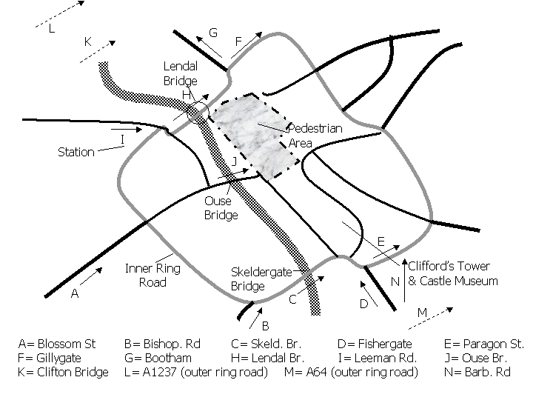
Figure 1: The Lendal Bridge Study Survey Sites

The first study took place between June and October 2000. The aim of the study was to monitor the closure of Lendal Bridge, part of York's inner ring road. A diagram of the final study is shown in Figure 1. The closure took place on the 11th of September 2000 and was planned to last for over a month. The bridge was closed to all vehicles but left open for public transport and cycles.

As can be seen from the diagram, not only is the bridge part of the inner ring road but it is also one of only three river crossings available to vehicles in the centre of York (three other bridge crossings are also available further out from the city centre, two of them on the outer ring road). In order to maximise the number of vehicles observed at several points on their route, it was decided to attempt to capture those vehicles which were making a journey from the south or west part of the city to the north or east. These vehicles would obviously have to cross a bridge somewhere. The sites chosen were chosen with the idea of capturing vehicles at three points on their journey: once on the southwest side of the river; once as they cross; and once on the northeast side of the river. Survey days were chosen with regard to the considerations mentioned above.

Table 2 shows the days that were surveyed for the Lendal Bridge study. Unfortunately, the day that the bridge closed coincided with the beginning of the UK Fuel Crisis. Because of a blockade of petrol depots by a group protesting high fuel tax, petrol supplies in the UK were extremely limited for the entire week. This had a major effect on the flows throughout the city for the first week of closure. Surveys were rescheduled to try and avoid these effects and to concentrate on monitoring the bridge reopening. The bridge reopening coincided with the flooding of the city of York in October 2000. The Lendal Bridge study was abandoned at this point. The analysis of the fuel crisis data is of interest in itself and a report on this is available for download from the project web site (Clark 2001b). Note that, because the bridge was fully closed, this freed up an extra surveyor who was used at site N during the closure. This was identified as a possible rerouting for the closure using SATURN modelling.
Day | Survey | Comment
27th June 2000 | Before Survey (not site N) | Early before survey to establish the repeatability of traffic patterns and the expected change between months.
28th June 2000 | Before Survey (not site N) | Early before survey to establish the repeatability of traffic patterns and the expected change between months.
6th Sept 2000 | Before Survey (not site N)
7th Sept 2000 | Before Survey (not site N)
8th Sept 2000 | Before Survey (not site N) | Final weekday before closure.
11th Sept 2000 | During Survey (not site H) | First day after closure. This also marks the first day of the UK fuel crisis.
13th Sept 2000 | During Survey (not site H) | Third day after closure. This was the third day of the UK fuel crisis (and marked a low point for flows.
27th Sept 2000 | During Survey (not site H)
18th Oct 2000 | During Survey (not site H) | Last day before planned reopening.
Table 2: Lendal Survey Summary

Fishergate Study
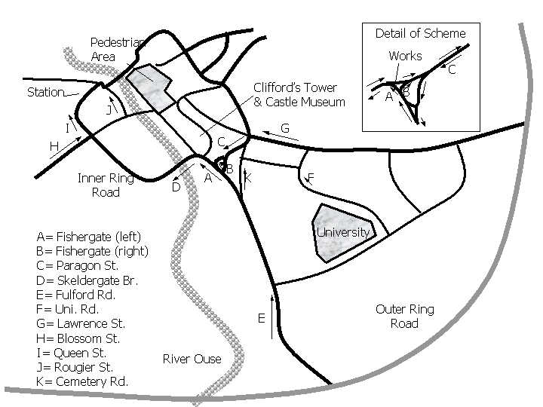
Figure 2: The Fishergate Study Survey Sites
The Fishergate Study is shown in diagrammatic form in Figure 2. This survey was based around works to repair a collapsed sewer at site A. The repair work involved a partial closure, essentially one lane being removed from the road. The closure was originally scheduled to last only two weeks and therefore the plan was to survey for one week before, one week during and one week after the closure. However, the closure was extended to four weeks and therefore no true after survey data is available with the possible exception of the 13th of July when the closure was temporarily suspended to allow for the increase in traffic due to a major horse racing event that weekend (the extra traffic due to the race-goers is thought not to have had a great effect on traffic during the morning peak).

Day | Survey | Comment
25th June 2001 | Before Survey
26th June 2001 | Before Survey
27th June 2001 | Before Survey
28th June 2001 | Before Survey
29th June 2001 | Before Survey
2nd July 2001 | During Survey | Partial closure occurred at 9:15 and should not affect the data collected.
3rd July 2001 | During Survey | First day of partial closure.
4th July 2001 | During Survey
5th July 2001 | During Survey
6th July 2001 | During Survey
11th July 2001 | During Survey
12th July 2001 | During Survey
13th July 2001 | After Survey | Road works removed to ease traffic for a race meeting in York. (The traffic should not be early enough in the day to interfere significantly with the survey). This can be considered to be an after survey day.
16th July 2001 | During Survey | Road works put back in place.
Table 3: Fishergate Survey Summary

Initial Data Analysis
A number of issues are worth mentioning related to analysis of the data. Firstly there is the problem of false matches that arises because the survey was only of partial plates. This is a complex problem which has been much discussed in the literature: see, amongst others, (Hauer 1979), (Maher 1985) and (Watling 1994). The particular needs of this survey required the extension of these methods to matches for more than pairs of sites. This work can be found in (Liu 2002) and (Clegg 2002).

Secondly there is the problem of missed journey ends. That is to say those vehicles that are seen at one site but are not seen at a second site, not because that was not on their route but because the survey at the second site ended before the vehicles were seen. It is difficult to avoid this problem totally but it can be mitigated by removing the end part of the data at the earliest seen site to such an extent that all vehicles seen at that site would complete their journey.

Thirdly there is the problem of errors in data recording. Great efforts were made to avoid the most common sources of error. Preliminary surveys found that a primary source of errors was the mistaken transcribing of letters that sound alike (N and M for example). This was reduced by encouraging surveyors to use a phonetic alphabet and also by minimising the reliance on letters by primarily recording digits.

(Clark 2001c) gives more information about the initial data analysis. Figures 3 and 4 and Table 4 (taken from the previously mentioned report) show an initial matching of licence plates on the Fishergate data. These figures show clearly the problem with the false matches. In both figures, the x-axis represents minutes past midnight at which a vehicle was seen at site E (so 480 represents 8:00am and 540 represents 9:00am). The y-axis shows the minutes elapsed until a vehicle with the same licence plate was recorded at site A. It should be assumed that the majority of the points in the smooth curve at around 6 minutes in figure 3 and rising from 6 to 25 minutes in figure 4 are true matches and the majority of the scatter of points off this are false matches. The first day after closing shows a large rise in travel time at the end of the rush hour period as opposed to the rise then decline throughout the rush hour period which typifies the before data.
Figure 3: Arrival Time at E vs Travel Time A to E 2/7/01

Figure 4: Arrival Time at E vs Travel time A to E 3/7/01

Date | Flows |  |  |  |  | Journey time mean |  |  |  | Journey time standard dev.
Date | EA | EB | EK | EF | E total | EA | EB | EK | EF | EA | EB | EK | EF
26/6 | 243 | 15 | 205 | 50 | 1044 | 9.18 | 10.53 | 8.60 | 7.43 | 1.74 | 1.95 | 1.32 | 1.16
27/6 | 234 | 15 | 215 | 49 | 966 | 9.38 | 9.51 | 9.05 | 8.15 | 2.17 | 1.67 | 2.61 | 2.61
28/6 | 258 | 13 | 251 | 50 | 1131 | 8.32 | 8.50 | 5.36 | 7.30 | 3.03 | 1.64 | 1.83 | 1.83
29/6 | 257 | 19 | 235 | 59 | 1161 | 5.61 | 6.67 | 5.24 | 7.28 | 1.08 | 2.10 | 0.85 | 1.37
2/7 | 258 | 19 | 259 | 51 | 1195 | 5.96 | 5.62 | 5.46 | 7.14 | 1.63 | 1.57 | 1.06 | 1.12
3/7 | 235 | 11 | 303 | 52 | 1134 | 12.52 | 9.47 | 6.43 | 6.82 | 8.08 | 4.88 | 3.19 | 1.01
4/7 | 231 | 12 | 282 | 56 | 1153 | 11.80 | 10.13 | 5.85 | 7.39 | 5.62 | 3.10 | 1.90 | 1.84
5/7 | 230 | 13 | 295 | 67 | 1174 | 10.79 | 10.49 | 4.84 | 7.05 | 5.05 | 7.52 | 0.93 | 2.01
6/7 | 253 | 13 | 294 | 59 | 1188 | 8.22 | 6.12 | 4.73 | 6.91 | 4.06 | 2.22 | 1.04 | 1.29
11/7 | 231 | 10 | 266 | 64 | 1113 | 8.31 | 12.89 | 5.01 | 7.57 | 4.90 | 7.91 | 1.35 | 2.34
12/7 | 244 | 13 | 275 | 52 | 1223 | 9.72 | 11.66 | 5.00 | 6.94 | 4.69 | 8.06 | 1.33 | 0.76
13/7 | 226 | 14 | 273 | 96 | 1265 | 5.21 | 6.59 | 4.60 | 7.63 | 1.05 | 3.33 | 0.96 | 1.78
16/7 | 272 | 17 | 288 | 58 | 1246 | 9.33 | 9.26 | 4.97 | 6.40 | 5.37 | 4.94 | 1.26 | 0.77
Table 4: Travel Times and Flows for the Selected Routes in the Fishergate Survey

Table 4 shows estimated corrected travel times and flows for the most important sites on the Fishergate survey. The shaded rows are data collected when the partial closure at site A was in place. (It should be noted that site B was always known to be a low flow site but was recorded in case it became a diversion route). It is significant that there is a considerable variation in the travel times in the before case. The most significant flow which was most affected by the closure was from site E to site A. It can be seen that the initial effect of the closure was extremely significant (more than doubling the mean travel time compared to the previous day). It is interesting to note that this increase dies off in subsequent days and, the travel times return to levels comparable with the before case even though there was no significant reduction in flow measured.

The STEER Model
The STEER model was developed at the University of York for the purposes of looking at driver route choice – specifically the interaction of route choice with signal settings. For the purposes of this paper, the model can be thought of as an iterative process that moves between two procedures: the first assigns traffic to routes and the second simulates the traffic once routes have been assigned. The demand in STEER is usually thought of as a fixed input from an Origin Demand (OD) matrix.
Figure 5: The STEER Model
The structure of the STEER model can be seen in Figure 5. The initial inputs to the STEER model are, as usual with this type of traffic simulation model, the network information and the OD matrix information. In an initial iteration, shortest paths through the network are calculated assuming that all links are empty and moving at free-flow speeds. Vehicles are assigned to these shortest paths. A simulation is then performed using these route assignments to calculate new travel time information. The travel time information is disaggregated by time of day in order that the simulation has an estimate of the time taken to travel on a link at a given time of day. This allows the simulation to account for the dynamic nature of the traffic patterns in a rush hour.

The simulation stage of STEER is relatively simple. It is a micro-simulation but not a particularly detailed one. Vehicles are assumed to move at a free-flow speed down a link (this speed being associated with the link itself and part of the information associated with the link). Once the vehicles reach the end of the link they join a queue. Vehicles may exit this queue at a rate governed by:
- The saturation flow of the link.
- The state of traffic signals at the exit of the link (if any exist).
- The presence of oncoming traffic on opposing links (if it is a give way link).
- The length of the queue on the link that is being moved into (blocking back).

The simulation is split into time slices (usually these are fifteen minutes long) and the simulation model collects average travel times for each period. These average travel times are used to inform the route choice model.

The assignment model begins by calculating shortest paths for each origin destination pair on the network in each of the time slices (assuming a vehicle setting off in the middle of that time slice). The shortest path is shortest with relation to a generalised cost that accounts in a weighted manner for time, distance and any charges that may be placed on the link.

Modelling Results From STEER
An attempt was made to replicate the observed behaviour of the Fishergate capacity reduction using the STEER model developed at the University of the York. The STEER model was run for thirty-nine simulation days until it was hoped that equilibrium was reached. On the fortieth simulation day the Fishergate capacity reduction was put in place with the drivers completely unaware that this would happen. As can be seen from the graphs, the results were extreme with the delays in the morning rush hour hugely increased. The results shown are the travel times between sites E and A. On day thirty-nine the average travel time predicted by STEER was 8.04 minutes (this compares with 5.96 minutes in reality on the day before closure). On day forty, the average travel time predicted by STEER was 40.77 minutes (this compares with 12.5 minutes on the day after closure). As can be seen, in the STEER model the delays increase markedly throughout the rush hour period when the capacity restraints are in place. After forty simulated days of closure (day eighty of the simulation) the drivers in STEER had mostly rerouted away from the closure and the average travel time was reduced to 13.66 minutes. It is clear that the first day after closure response of the STEER model is far too extreme but the longer-term behaviour is more realistic. The final journey time had increased by 70% comparing the last day of simulation with the last day before the closure. In reality, this figure was 56% (comparing travel times between E-A on the last day before closure with the last day surveyed) but the real-life drivers had many response options not available to the simulated drivers, including the option not to travel (the modelled origin-demand matrix was fixed).

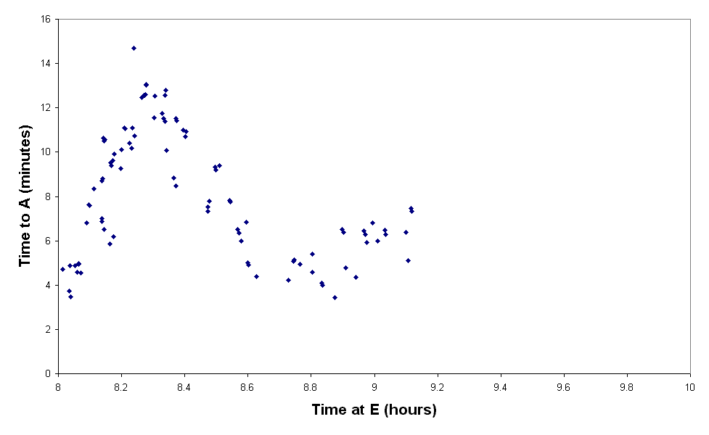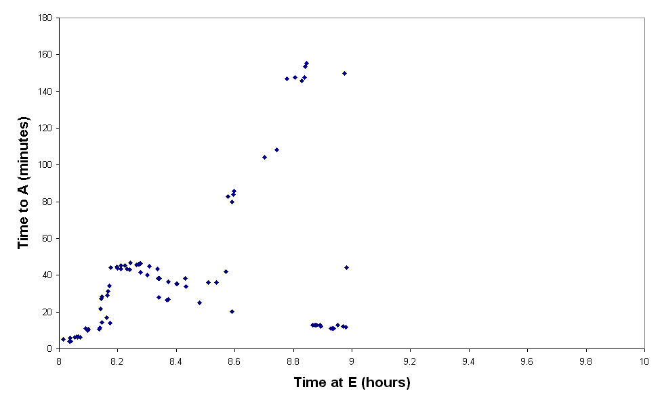
Figure 6: Results from the STEER model
These results should be compared with those in figures 3 and 4 above. While the absolute magnitude of the results is incorrect, it seems like the general pattern is correct. It is worth commenting that the real life travellers seem to be able to better respond to the intervention and more quickly reduce the effects of the intervention than the modelled travellers in STEER.

Conclusion
The main aim of this paper has been to advertise the existence of a data set that is freely available to researchers. The data set is downloadable from the web site as are all the publications from the project and a number of other documents that will give information on data analysis methods that have been tried. It is hoped that this data will be of considerable use to any researcher interested in problems related to route choice wishing to test their work in a practical context.

In this paper, an initial investigation into the data has been presented and an attempt to model it with a simulation model has been shown. It is clear that much more work could be done to improve on the simple modelling tried in this paper.

Bibliography
Batley RP, Clegg RG (2001): Driver Route and Departure Time Choices: The Evidence and the Models. Proc of the 33rd Annual UTSG conference (St Anne's College. Cambridge). Full paper available online at:
gridlock.york.ac.uk/route/docs/utsg2001.doc
Batley RP, Clark SD (2002): Estimation of Drivers' Route Choice Using Multi-Period Multinomial choice Models. In Proceedings of 13th MiniEURO conference and 9th EURO Working Group on Transportation (Bari, Italy) p59-63. Extended abstract available online at:
gridlock.york.ac.uk/route/docs/rbatleybari.doc
Cairns S, Carmen H-K, Goodwin P (1998): Traffic Impact of Highway Capacity Reductions: Assessment of the Evidence. Landor Publishing.
Clark SD (2001a): Report on Park Row Before Surveys. Available online at:
gridlock.york.ac.uk/route/docs/parkrow.pdf
Clark SD, Clegg RG (2001b): Assessing the Impact of United Kingdom Fuel Protest Actions in the City of York, United Kingdom. Available online at:
gridlock.york.ac.uk/route/docs/fuel.pdf
Clark SD (2001c): An Exercise In Matching Number Plates: Using a Maximum Likelihood Approach. Available online at:
gridlock.york.ac.uk/route/docs/maxlike.doc
Clegg RG (2002): A Set Theoretic Framework for Enumerating Matches in Surveys and Its Application to Reducing Inaccuracies in Vehicle Roadside Surveys. In Proceedings of 13th MiniEURO conference and 9th EURO Working Group on Transportation (Bari, Italy) p432-436 and submitted to European Journal of Operations Research. Extended abstract available online at:
gridlock.york.ac.uk/route/docs/rcleggbari.pdf
Duffell JR, Kalombaris A (1988): Empirical Studies of Car Driver Route Choice in Hertfordshire, Traffic Engineering and Control, 29 (7/8), pp398-408.
Hauer E (1979): Correction of Licence Plate Surveys for Spurious Matches. Transportation Research A 13A: 71-78.
Huff J, Hanson S (1986): Repetition and variability in urban travel. Geographical Analysis, 18 (2), pp97-114.
Jan O, Horowitz AJ, Peng Z-R (1999): Using GPS data to understand variations in path choice. Paper presented at the 78th meeting of the Transportation Research Board, Washington DC, January 1999.
Liu R (2002): Analysis of the Uncertainties in Day-to-Day Dynamic Models from Observed Choice Responses. In. Proceedings of 13th MiniEURO conference and 9th EURO Working Group on Transportation (Bari, Italy) p 247 – 25. Extended abstract available online at:
gridlock.york.ac.uk/route/docs/rliubari.doc
Maher M (1985): The Analysis of Partial Registration Plate Data. Traffic Engineering and Control. October: 495-497
Stephenson B, Tepley S. (1984): The verification of CONTRAM in Edmonton, Traffic Engineering and Control, 25 (7/8), pp376-385.
Watling DP (1994): Maximum Likelihood Estimation of an Origin Destination Matrix From a Partial Registration Plate Survey. Transportation Research B. 28B (3): 289-314

